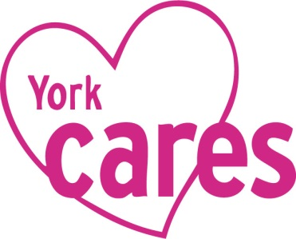
James’ Story
Work experience with York Cares

James moved back to the York area in 2013 having spent his teenage years in care. He returned to his birth mother but had a fractious relationship and no income in the household. He was immediately keen to find a job and his own place.

Although very sociable, James was a very vulnerable young man and he needed close support to be able to make his first steps to independence. When he was referred to York Cares he was keen to do something practical or mechanical and he started by getting an overview of different roles through two Behind-the-Scenes visits. After enjoying these, he moved onto a work placement with York Marriott Hotel in 2014.
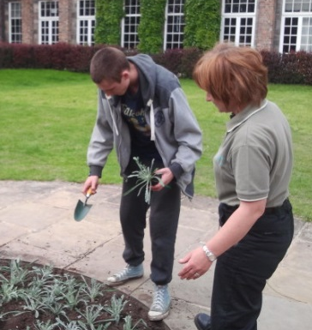
- York St John University hosted a day with the gardening team for a small group of care leavers. They toured the campus and learnt about the many roles of the team and then helped to plant out an area of the main courtyard.

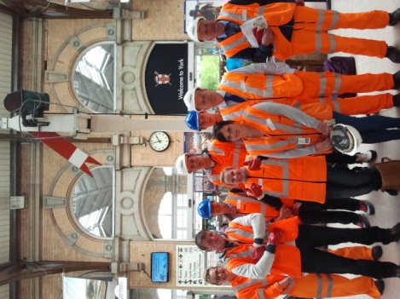
- Network Rail hosted a behind-the-scenes tour of York Station for a group of care leavers. The staff shared their experiences of getting into work and moving between jobs, before talking about their roles designing and maintaining stations along the East Coast Mainline. The day culminated in a tour of the station roof!

- York Marriott Hotel supported James with a placement in their Maintenance team for one day a week over six weeks. He was able to shadow members of the team and help with tasks around the hotel, providing him both with practical experiences and an opportunity to learn about the operations of an international hotel.

“The placement at York Marriott Hotel gave me a lot of confidence because people wanted to help me and thought I could do it”, James
A year later James moved closer to his birth dad and secured a job with the Highways Agency

York Cares is looking forward to working with the Careers and Enterprise Company and our partners locally at City of York Council, to enable more young people like James to benefit from tailored work experience.

York Cares
01904 323482, info@yorkcares.co.uk, @YorkCares

